**POWER BI**

**AMAZON PRIME VIDEO**

**WHAT IS POWER BI?**

Power BI is a collection of software services, apps, and connectors that work together to turn your unrelated sources of data into coherent, visually immersive, and interactive insights. Your data might be an Excel spreadsheet, or a collection of cloud-based and on-premises hybrid data warehouses. Power BI lets you easily connect to your data sources, visualize and discover what's important, and share that with anyone or everyone you want.

Power BI consists of several elements that all work together, starting with these three basics:

* A Windows desktop application called *Power BI Desktop*.
* An online software as a service (SaaS) service called the *Power BI service*.
* Power BI Mobile apps for Windows, iOS, and Android devices.

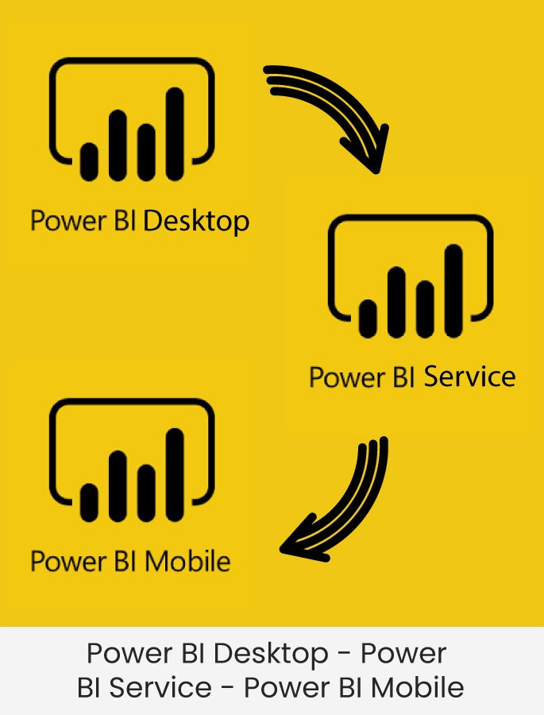

These three elements—Power BI Desktop, the service, and the mobile apps—are designed to let you create, share, and consume business insights in the way that serves you and your role most effectively.

Amazon Prime Video

The data set consists of the following columns:

* + Cast
  + Country
  + Date Added
  + Description
  + Director
  + Duration
  + Listed In
  + Rating
  + Releasing Year
  + Show Id
  + Title
  + Type

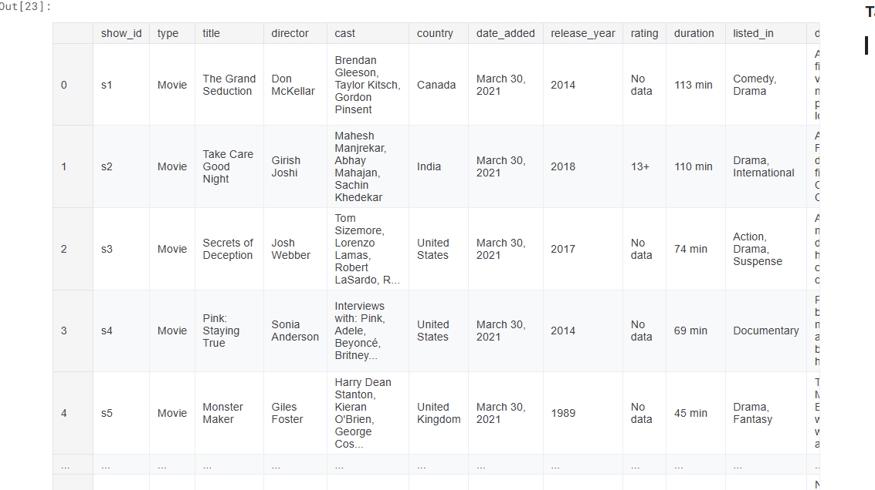

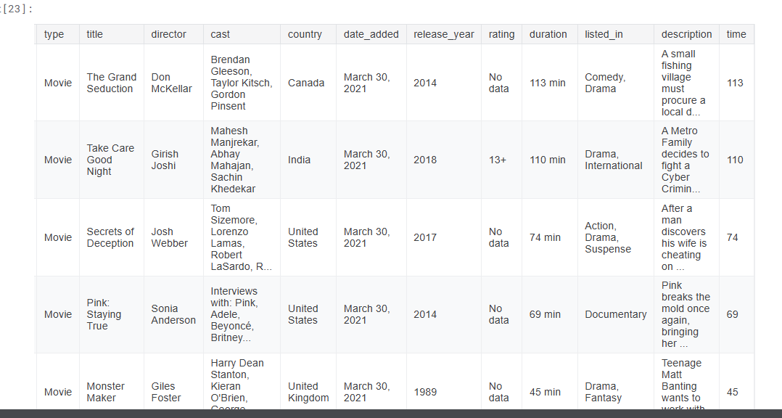

**Project Overview: Amazon Prime Video Dashboard**

**Objective:**

This dashboard was designed to analyze and present insights from Amazon Prime Video's dataset. It provides a detailed summary of the platform's content library, focusing on genres, ratings, countries, and release years.

**Key Features:**

1. **Content Metrics**:
   * **Total Titles**: Displays the total number of titles available (9,655).
   * **Total Ratings**: Shows the number of ratings (25), indicating user engagement.
   * **Total Directors**: Highlights the diversity of content creators (5,771).
   * **Total Genres**: Identifies 519 distinct genres in the library.
2. **Time Analysis**:
   * **Start and End Year**: Content spans from 1920 to 2021, showcasing the longevity and evolution of available titles.
   * **Release Year Analysis**: A trend chart visualizes the growth in the number of titles released over time, with a notable surge in recent years.
3. **Genre Analysis**:
   * A bar chart shows the number of shows per genre, highlighting the most popular genres such as *Action, Comedy, and Drama*.
   * Visual tiles categorize key genres, making the information visually intuitive.
4. **Geographical Insights**:
   * A world map identifies the total number of shows by country, emphasizing regional content distribution.
5. **Content Type Distribution**:
   * A pie chart separates the library into *Movies* (19.18%) and *TV Shows* (80.82%), providing insight into content type preferences.
6. **Rating column :**
   * **G (General Audiences): All ages admitted. There is no content that would offend parents if viewed by children.**
   * **PG (Parental Guidance Suggested): Some material may not be suitable for children. Parents are urged to give "parental guidance." May contain some material parents might not like for their young children.**
   * **PG-13 (Parents Strongly Cautioned): Some material may be inappropriate for children under 13. Parents are urged to be cautious. Some content may be inappropriate for pre-teenagers.**
   * **R (Restricted): Restricted to viewers over 17, unless accompanied by a parent or adult guardian. Contains some adult material. Parents are urged to learn more about the movie before taking their children to see it.**
   * **NC-17 (Adults Only): No one 17 and under admitted. Clearly adult. Children are not admitted.**
   * **TV-Y: Suitable for all children, especially those aged 2-6.**
   * **TV-Y7: Suitable for children aged 7 and older. May include mild fantasy violence.**
   * **TV-Y7-FV: Suitable for children aged 7 and older, with fantasy violence.**
   * **TV-G: General audience. Suitable for all ages.**
   * **TV-PG: Parental guidance suggested. May contain material unsuitable for younger children.**
   * **TV-14: Parents strongly cautioned. May contain material inappropriate for children under 14.**
   * **TV-MA: Mature audiences only. Not suitable for children under 17.**

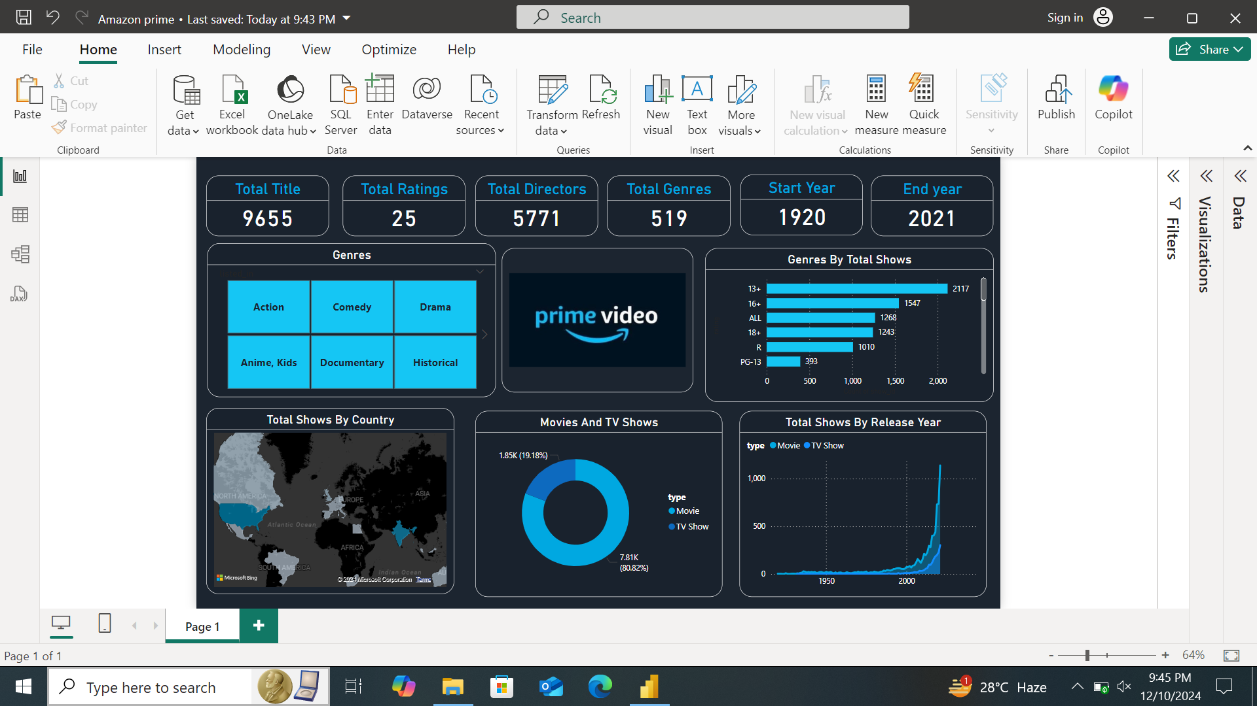

**Insights:**

* **Genre Popularity**: Action, Comedy, and Drama dominate, indicating preferences.
* **Regional Insights**: The map pinpoints active content-producing countries, enabling targeted regional strategies.

**Tools and Techniques:**

* **Power BI**: Used for data visualization and interactivity.
* **Key Visuals**: Included bar charts, maps, and pie charts for intuitive analysis.
* **Advanced Features**: KPIs and time-series trends for detailed insights.

**Conclusion:**

This dashboard serves as a comprehensive tool for analyzing Amazon Prime Video's content library. It can help stakeholders understand viewer preferences, track growth trends, and make informed decisions for content acquisition and regional strategies.